PHYSICAL FINANCE · CLIMRISK RESEARCH
INDIA SERIES · No. 2 · Heat Stress & Labour Productivity · August 2026
The Productivity Tax
What Extreme Heat Costs India Before It Appears in Any Model
India's informal workforce — more than 90 percent of all employment — has no air conditioning, no paid sick leave, and no financial buffers when heat forces them to stop working. As heatwave days multiply and wet-bulb temperatures climb, the loss accumulates in sectors that standard financial models do not systematically monitor.
By Shrinivash D Kannan · Founder, ClimRisk
On 29 May 2024, the India Meteorological Department recorded temperatures above 45°C across large parts of Rajasthan, Uttar Pradesh, and Haryana simultaneously. [IMD Heat Watch 2024] Heat-related deaths were reported in Delhi, Odisha, and Bihar. Schools were shut. Outdoor construction work in several cities ceased by 10am. The NDMA issued advisories across eleven states. [NDMA 2024]
None of this appeared in any quarterly earnings model for an Indian FMCG company, real estate developer, or agricultural lender. The loss was invisible — not because it was small, but because the analytical frameworks used by most financial institutions do not have a systematic method for converting atmospheric temperature into financial output.
This article builds that method. It traces the physical mechanism by which extreme heat suppresses labour output, maps the six financial transmission pathways into which that suppression flows, and uses ILO and NGFS Phase 4 data to quantify what the loss looks like under three warming scenarios through 2050. [ILO 2019] [NGFS Phase 4]

90%+  India's Informal Workforce  More than 90% of employed Indians work without air conditioning, paid sick leave, or employer health protection.  PLFS 2022–23, Ministry of Statistics | 5.3%  Working Hours Lost by 2030  ILO projects South Asia will lose 5.3% of all working hours annually to heat stress by 2030 under current warming.  ILO, "Working on a warmer planet" (2019) | 35°C  Wet-Bulb Temperature Limit  At a wet-bulb temperature of 35°C, the human body cannot cool itself. Sustained outdoor work becomes physiologically impossible.  Sherwood & Huber, PNAS (2010)

The Physical Mechanism: Why Heat Kills Productivity Before It Kills Workers
The human body maintains a core temperature of approximately 37°C. When ambient temperature and humidity rise, the body diverts blood flow from muscles to the skin surface. [IPCC AR6 WGII Ch.16] Physical work capacity falls. Reaction time slows. Decision-making degrades. At a wet-bulb globe temperature (WBGT) above 28°C, outdoor workers at moderate intensity lose an estimated 50 percent of their sustainable work capacity. [ILO 2019: WBGT >28°C = 50% capacity loss at moderate work rate]
Wet-bulb temperature accounts for humidity — it is the lowest temperature a surface can reach through evaporative cooling. At 35°C wet-bulb, the human body cannot cool itself even in full shade with unlimited hydration. [Sherwood & Huber, PNAS 2010] No amount of rest prevents core temperature from rising toward dangerous levels. Work must stop.
SOURCE — IPCC AR6 Working Group II, Chapter 16 (Key Risks)
"Heat stress is among the most broadly impactful physical climate hazards for human health and labour productivity."
Labour productivity losses from heat stress are projected to increase non-linearly with warming. At 1.5°C, global losses reach approximately 2.2 percent of working hours. At 2.0°C, they reach 3.8 percent. The losses are geographically concentrated in tropical regions — agriculture, construction, utilities, and informal manufacturing.
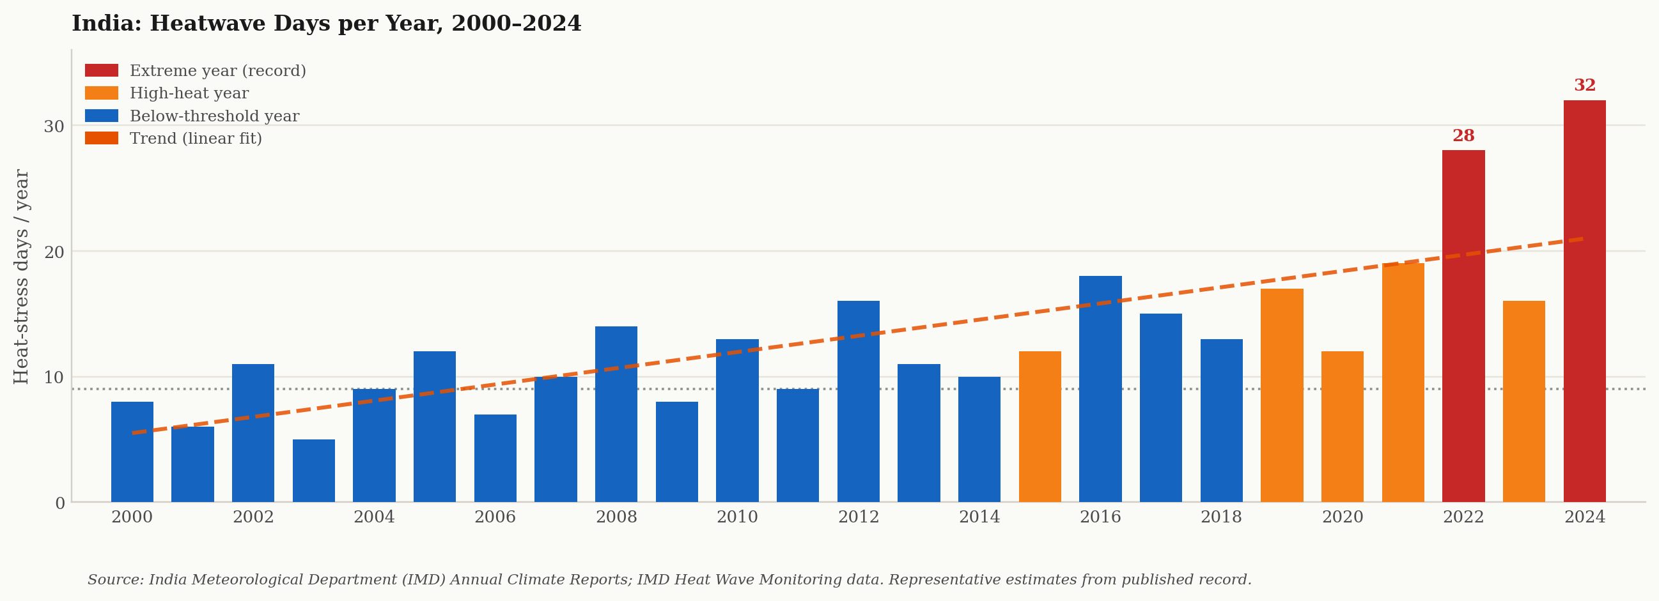
India: Heatwave days per year, 2000–2024. Red bars mark record or near-record years. Upward trend consistent with IMD data. Source: IMD Annual Climate Reports.
SOURCE — IMD Annual Climate Summary and Heat Wave Reports
India's heatwave footprint is expanding in both intensity and geographic reach.
The northwest, central, and eastern India regions have experienced a statistically significant increase in heatwave frequency and duration since 1950. The 2022 northwest India heatwave — the earliest on record, peaking in late March — demonstrated that heat stress now arrives before the traditional May–June season that agricultural and construction calendars assume.
Who Bears the Cost: India's Informal Workforce
India's Periodic Labour Force Survey for 2022–23 records that more than 90 percent of India's employed workforce is in informal employment. [PLFS 2022–23] This means: no employer-provided health insurance, no air-conditioned workspace, no paid sick leave. The productivity loss that heat imposes on this population does not appear on any corporate balance sheet. It appears — much later — in agricultural credit NPA ratios, rural consumer demand figures, and informal sector output indices. [RBI FSR 2023]
Agriculture employs an estimated 600 million people across rural India. Kharif cultivation peaks in June through August, exactly the window of highest heat-humidity combination in the Indo-Gangetic Plain. Construction employs approximately 60 to 65 million workers. [ILO 2019: Construction sector loses 5.6% of working hours at 1.5°C warming] Both sectors are dominated by daily-wage labour — workers paid only when they work, who cannot afford to stop.
"The worker who stops when it is 47°C does not file a productivity report. The loss accumulates invisibly — in informal incomes, in food output, in rural demand — until it reaches a balance sheet many steps removed from the original temperature."
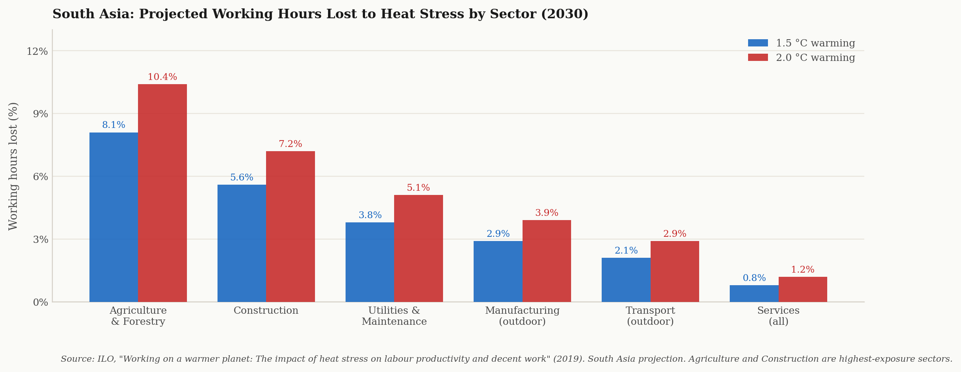
South Asia: Projected working hours lost to heat stress by sector, 2030. Agriculture and construction carry the highest exposure at both 1.5°C and 2.0°C warming. Source: ILO, "Working on a warmer planet" (2019).
SOURCE — ILO, "Working on a warmer planet: The impact of heat stress on labour productivity and decent work" (2019)
South Asia is the most exposed region in the world to heat-related working hour losses.
By 2030, South Asia is projected to lose approximately 5.3 percent of total working hours annually to heat stress — the highest regional exposure globally. India accounts for the largest share. Agriculture loses an estimated 8.1 percent of working hours at 1.5°C warming and 10.4 percent at 2.0°C.
Six Financial Transmission Pathways
Heat stress does not stop at the individual worker. It moves through the economy along six pathways that are distinct in their financial character but simultaneous in their occurrence.
1. Agricultural Output Compression [FAO · IMD] Kharif crops cultivated at heat-humidity conditions above WBGT thresholds produce lower yields regardless of rainfall adequacy. High night-time temperatures during grain-filling stages of rice permanently suppress output per hectare. This moves from atmospheric temperature into FCI procurement volumes, MSP pressure, and food inflation the RBI must address.
2. Agricultural Credit NPA Pressure [RBI FSR] Informal daily-wage farm labour that loses income during peak heat periods cannot service agricultural input loans. Scheduled commercial bank NPA ratios in the agriculture segment have documented sensitivity to temperature anomaly years. The failure to embed heat stress into credit underwriting means NPA risk is systematically underpriced.
3. Construction Sector Output and Developer Credit [NHB · CRISIL] Construction activity halts during peak heat periods. The 2024 NDMA heat action advisories explicitly cited construction worker safety as the trigger for work stoppages in Delhi NCR, Rajasthan, and UP. Project timelines extend. Real estate developer cash flows face additional compression from heat-forced delays.
4. FMCG Rural Revenue and Earnings Impact [Company Filings · CMIE] Rural India contributes 35 to 40 percent of FMCG company revenues. The informal rural workforce loses earned income on heat-stop days — and that income loss reduces consumption of packaged food, personal care, and household products within the same quarter. Companies including HUL have cited rural volume growth as the single most variable input in quarterly earnings commentary.
5. Energy System Stress [CEA · MoP India] Extreme heat drives a simultaneous cooling demand spike and a supply-side constraint: thermal power plant efficiency falls as ambient temperature rises; water availability for cooling towers reduces. India's Ministry of Power documented grid stress events during both the 2022 and 2024 heatwaves. Discoms with already-stressed balance sheets face higher short-term power purchase costs.
6. Sovereign Fiscal Exposure and Long-Term Human Capital Discount [World Bank · IMF] The Government of India bears direct heat costs through MGNREGS wage disbursements, NDMA heat action plan funding, and public health system pressure. The World Bank has documented that repeated heat exposure during childhood produces measurable long-term cognitive and physical productivity deficits — a human capital depreciation that suppresses sovereign GDP potential over decade-scale time horizons.
SOURCE — Reserve Bank of India, Financial Stability Report (June 2023) and Annual Report (2023–24)
India's financial system has not yet systematically embedded heat stress into credit risk frameworks.
The RBI's climate risk guidance documents identify physical risk — including extreme heat events — as a material consideration for bank stress testing. However, heat stress as a distinct, quantifiable driver of agricultural NPA formation, construction finance delinquency, and informal sector income collapse is not yet reflected in the standardised credit risk models used by most scheduled commercial banks.
What Climate Science Says About India's Heat Trajectory Through 2050
IPCC AR6 WGI Chapter 11 is explicit on the India heat trajectory. [IPCC AR6 WGI Ch.11] Under current policies, India is projected to see: a statistically significant increase in days when WBGT exceeds the moderate-risk threshold for outdoor workers; a higher frequency of concurrent heat and humidity events; and an extension of the heat-stress season from the traditional May–June window into March–April and September–October. [IPCC AR6 WGI Ch.11: Rare 1-in-50-year heat events become 1-in-5-year events at 2°C warming]
The financial consequence is not simply that heat events become more frequent. It is that the economic system — construction schedules, agricultural calendars, MGNREGS work schedules — is calibrated to a heat pattern that no longer reflects physical reality. Every additional week of heat-stop conditions outside the traditional assumed window is an uncalibrated loss. [Systematic model gap: heat seasonality shift unpriced in most India credit models]
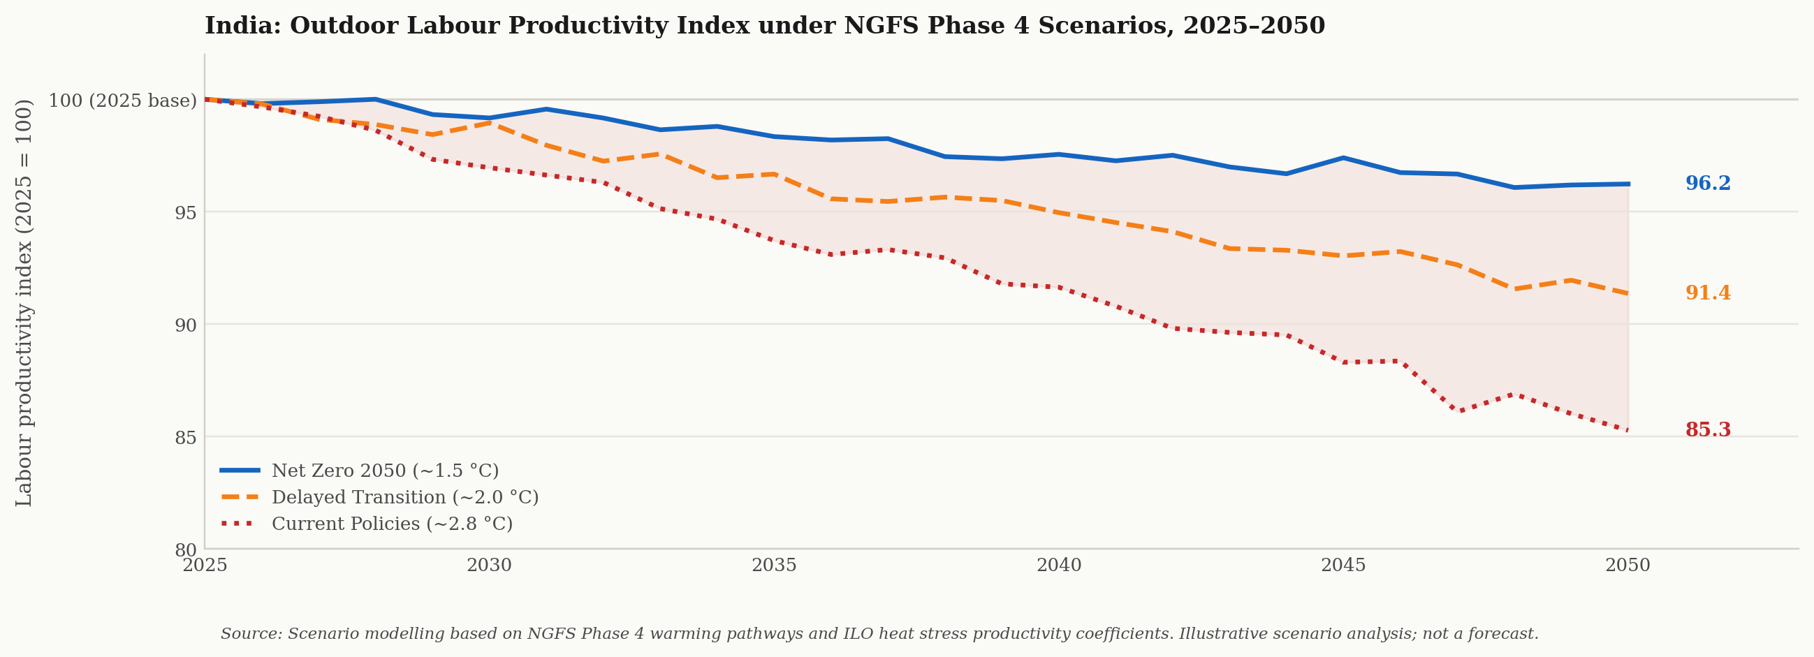
India: Outdoor labour productivity index under NGFS Phase 4 scenarios, 2025–2050 (2025 = 100). Under Current Policies (~2.8°C), the cumulative productivity tax by 2050 is approximately 15 index points. Source: NGFS Phase 4; ILO productivity-temperature coefficients.
SOURCE — IPCC AR6 Working Group I, Chapter 11 (Weather and Climate Extremes)
"Heat extremes have increased in frequency and intensity in India since the 1950s and are virtually certain to intensify further under all warming scenarios."
Under 2°C of global warming above pre-industrial levels, heat events that currently occur once in 50 years are projected to occur once in approximately 5 years. Under 4°C, they become near-annual. For India's outdoor workforce, this represents a structural shift in the number of physiologically constrained work-days per year — a permanent, compounding drag on labour productivity.
Financial Impact Summary: Heat Stress by NGFS Scenario

Financial Impact Area | Net Zero ~1.5°C | Delayed ~2°C | Current ~2.8°C
Agricultural output loss (kharif season) | Moderate | High | Severe
Agricultural credit NPA pressure | Moderate | High | Severe
Construction finance / developer credit | Moderate | High | High
FMCG rural revenue compression | Moderate | High | Severe
Energy / Discom credit stress | Moderate | High | Severe
Sovereign fiscal and human capital cost | Moderate | High | Severe

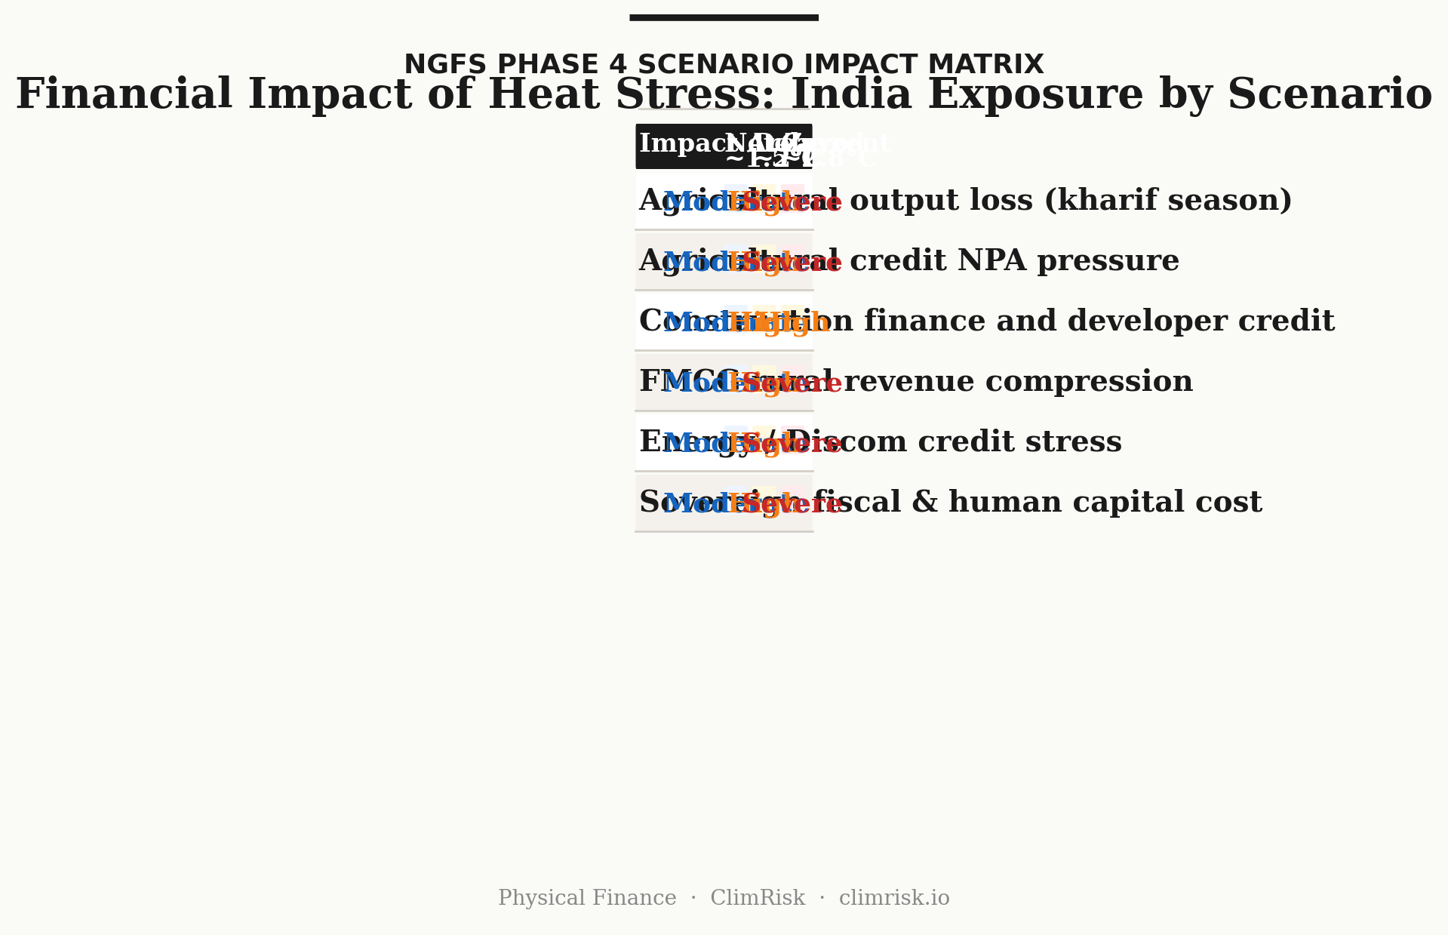
Scenario impact matrix — Moderate / High / Severe across six financial transmission pathways under three NGFS Phase 4 warming scenarios.
What This Means for Capital Allocation
The 2024 India heatwave produced documented, measurable output consequences in construction, agriculture, and retail foot traffic. Grid stress events were recorded. NDMA advisories halted outdoor work across eleven states. Public health systems in Delhi and Odisha faced demand spikes. [NDMA 2024 · MoP India 2024] None of this was reflected as a quantified risk in any quarterly earnings guidance issued by India-focused equity analysts, agricultural lenders, or infrastructure finance companies during the same period.
The physics is not uncertain. The IMD has 150 years of temperature records. The ILO has published heat-productivity coefficients by sector. [ILO 2019] The IPCC has published warming trajectories with quantified regional heat event probability changes under each scenario. [IPCC AR6 WGI Ch.11] The gap is not in the physical data. The gap is in the analytical framework that converts the physical data into financial terms — at the asset level, portfolio level, and sovereign level.
"The heat stopped outdoor construction across eleven states simultaneously. No financial model had a field for it."
Standard credit risk models for India's agricultural lending segment do not incorporate WBGT thresholds or ILO heat-productivity coefficients into NPA probability distributions. Equity research covering FMCG companies does not systematically embed heat-stress days into rural consumption forecasts. Infrastructure finance models do not adjust construction timeline assumptions for an expanded heat-stop season. The systematic omission of this physical variable creates a consistent, directional mispricing of risk — concentrated in the informal economy, but transmitting eventually into formal financial institutions through the six pathways mapped above.
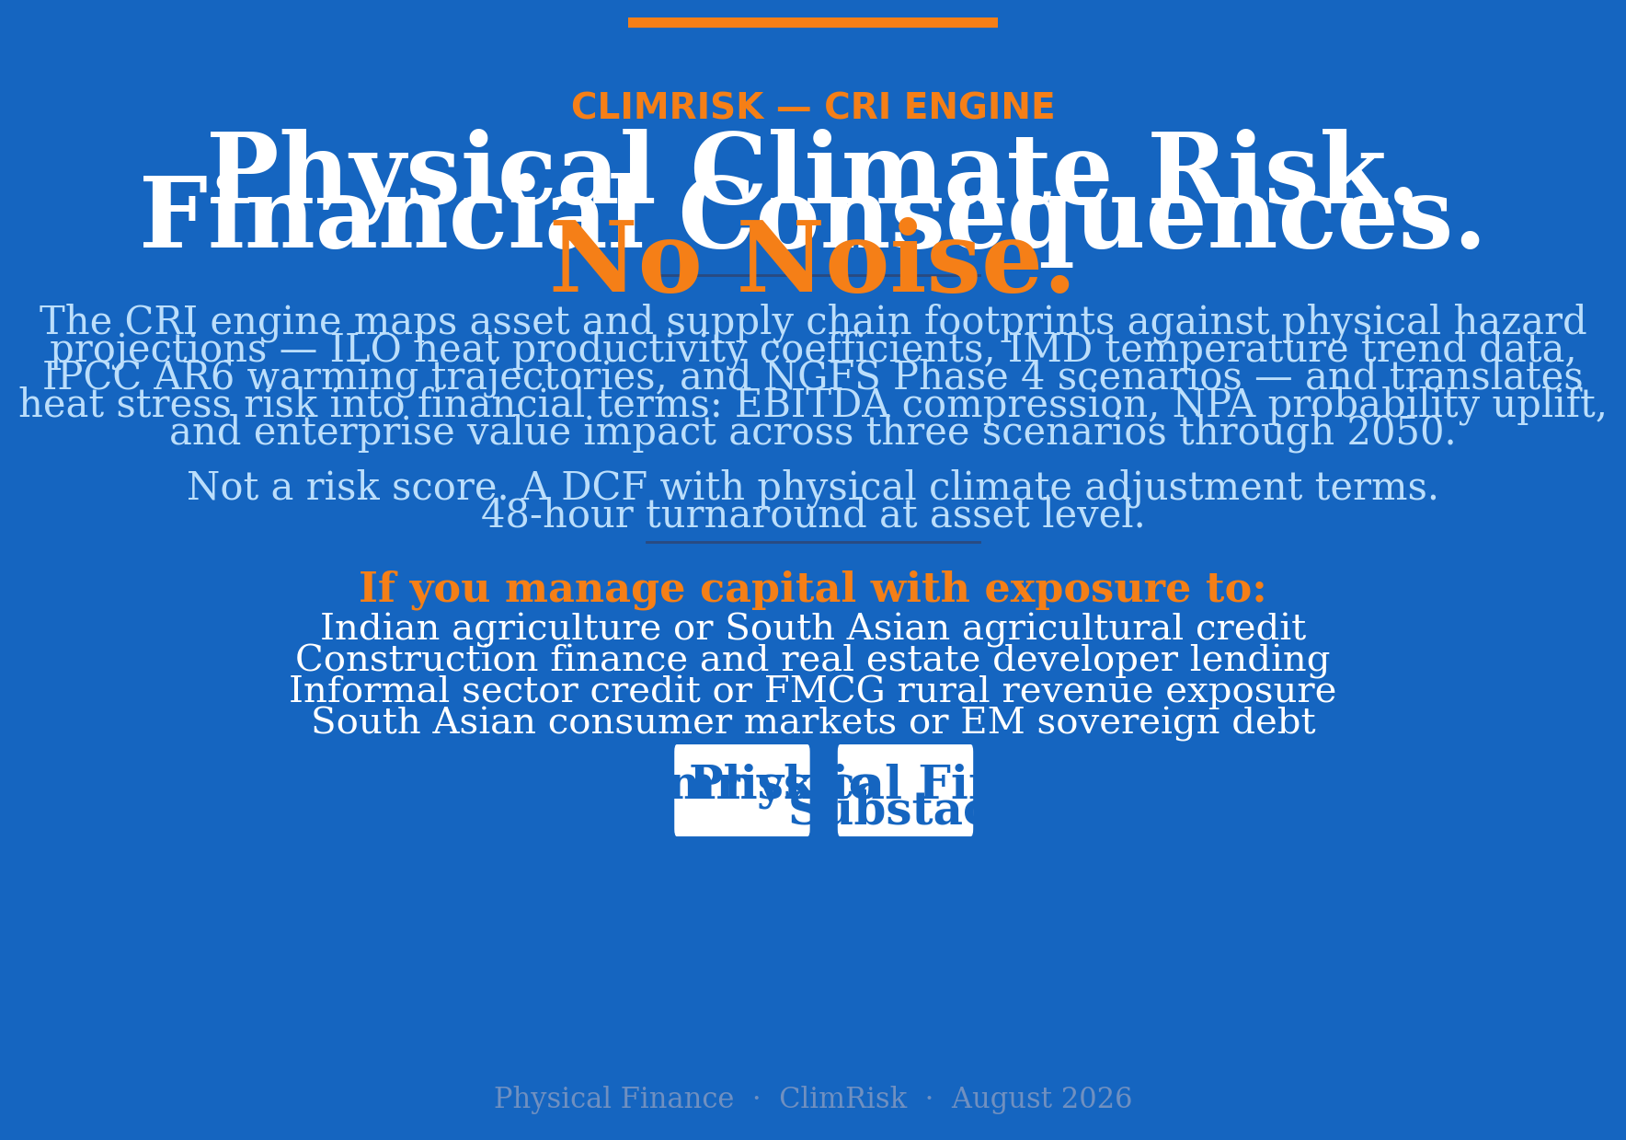

ClimRisk — CRI Engine
The CRI engine maps asset and supply chain footprints against physical hazard projections — ILO heat productivity coefficients, IMD temperature trend data, IPCC AR6 warming trajectories, and NGFS Phase 4 scenarios — and translates heat stress risk into financial terms: EBITDA compression, NPA probability uplift, and enterprise value impact across three scenarios through 2050. Not a risk score. A DCF with physical climate adjustment terms. 48-hour turnaround at asset level.
If you manage capital with exposure to Indian agriculture, construction finance, informal sector credit, or South Asian consumer markets, and want to see what physically-grounded heat stress quantification looks like in practice, I would like to speak with you.
climrisk.io
DATA SOURCES
India Meteorological Department (IMD) — Annual Climate Summaries and Heat Wave Reports · International Labour Organization — "Working on a warmer planet" (2019) · IPCC AR6 Working Group I Chapter 11 and Working Group II Chapters 5 and 16 · National Disaster Management Authority (NDMA) — Heat Action Plan Advisories 2022–2024 · Reserve Bank of India — Financial Stability Reports (June 2022, June 2023) and Annual Report 2023–24 · Ministry of Statistics — Periodic Labour Force Survey 2022–23 · Central Electricity Authority of India — Power Supply Position Reports 2022, 2024 · NGFS Phase 4 Scenario Documentation · World Bank — "The Economics of Heat Stress: Labour Productivity and Adaptation Costs" (2022) · Sherwood, S.C. and Huber, M. — "An adaptability limit to climate change due to heat stress" (PNAS, 2010)

